Given a binary tree, find its minimum depth.

The minimum depth is the number of nodes along the shortest path from the root node down to the nearest leaf node.

**Note:** A leaf is a node with no children.

**Example 1:**

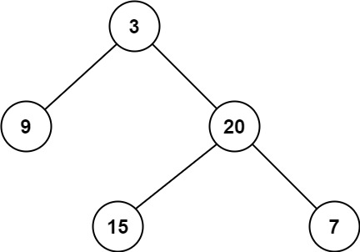

**Input:** root = [3,9,20,null,null,15,7]

**Output:** 2

**Example 2:**

**Input:** root = [2,null,3,null,4,null,5,null,6]

**Output:** 5

**Constraints:**

* The number of nodes in the tree is in the range [0, 105].
* -1000 <= Node.val <= 1000